Assignment 1 – File Permissions • • • •
Create a directory named project Inside it, create a file run.sh Give execute permission only to the owner Verify permissions using ls -l
First, I make a shell script AS1.sh
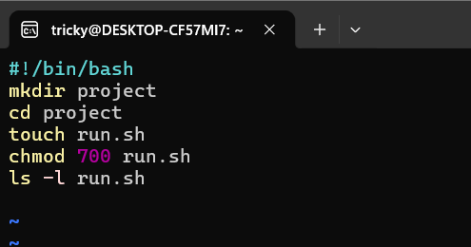
After that I give execute permission (chmod u+x AS1.sh) to run
AFTER Running the script with
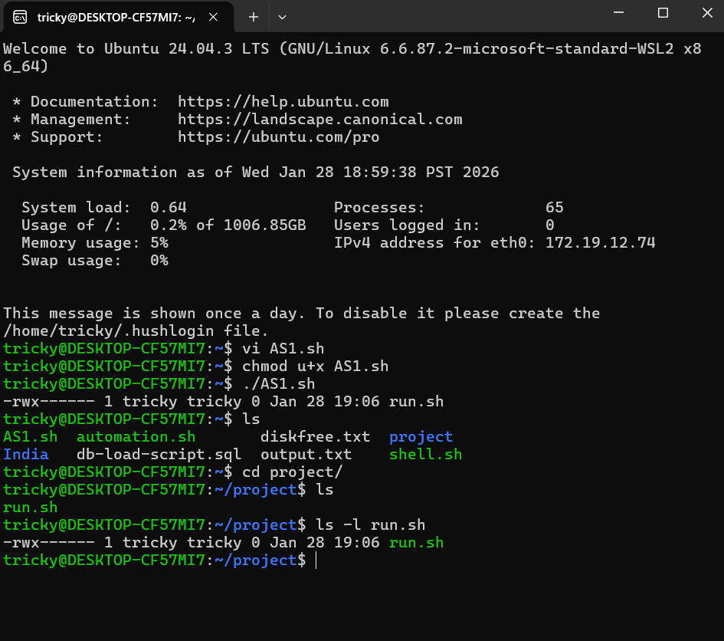
Assignment 2 – vi Editing Basics • • • • •
Create a file config.txt using vi Add 5 lines of text Delete the 3rd line Undo once Save and quit
Make file with - vi config.txt
Go to then insert mode with pressing i
Then added random 5 line.
Press to exit insert mode.
Make sure your cursor is on the 3rd line.
Then type -dd This deletes the current line (the 3rd one).
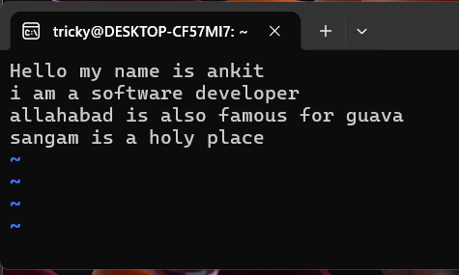
restores the deleted line- TYPE u
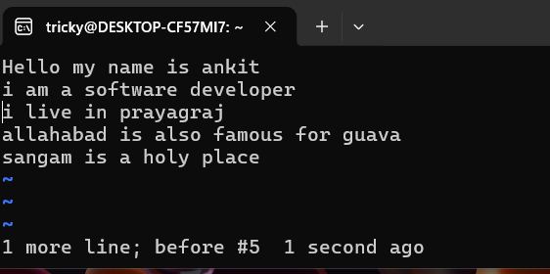
SAVE AND QUIT - :wq

Assignment 3 – vi Search & Replace • • • •
Create a file app.env Add the following lines: ENV=prod PORT=3000 LOG=enabled Using vi , replace prod with Save the file
Created a file using vi – vi app.env
Press i to enter insert mode.
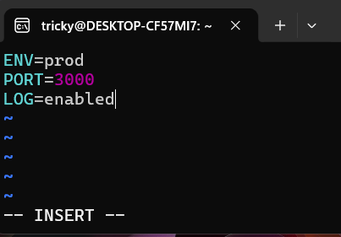
Press ESC to exit insert mode.
Replace prod with production
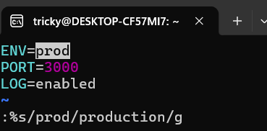
:%s/prod/dev/g
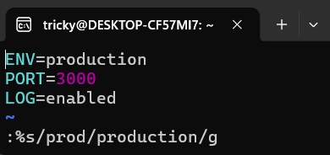
SAVE AND QUIT - :wq

Assignment 4 – Process Management • • • •
Run a background process using sleep Find its PID Stop the process gracefully Verify that it has stopped

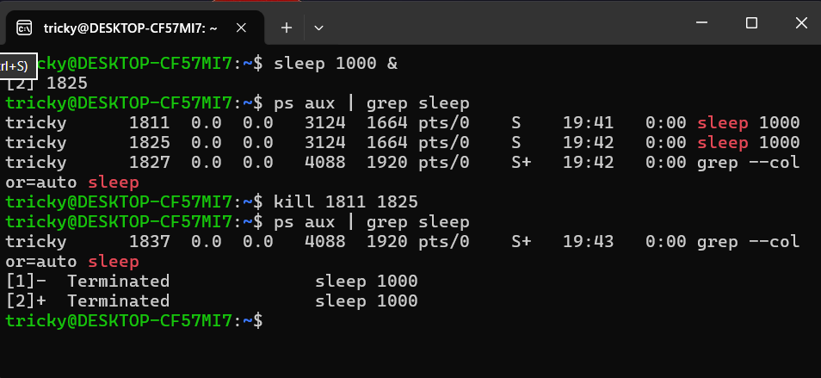

Assignment 5 – Install Jenkins • • • • Install Jenkins on Ubuntu Start the Jenkins service Enable Jenkins to start on boot Verify that Jenkins is running
For that I write a shell script to install Jenkins
First I make a file vi installjenkins.sh
Give execute permission with chmod u+x installjenkins.sh
Then execute to install
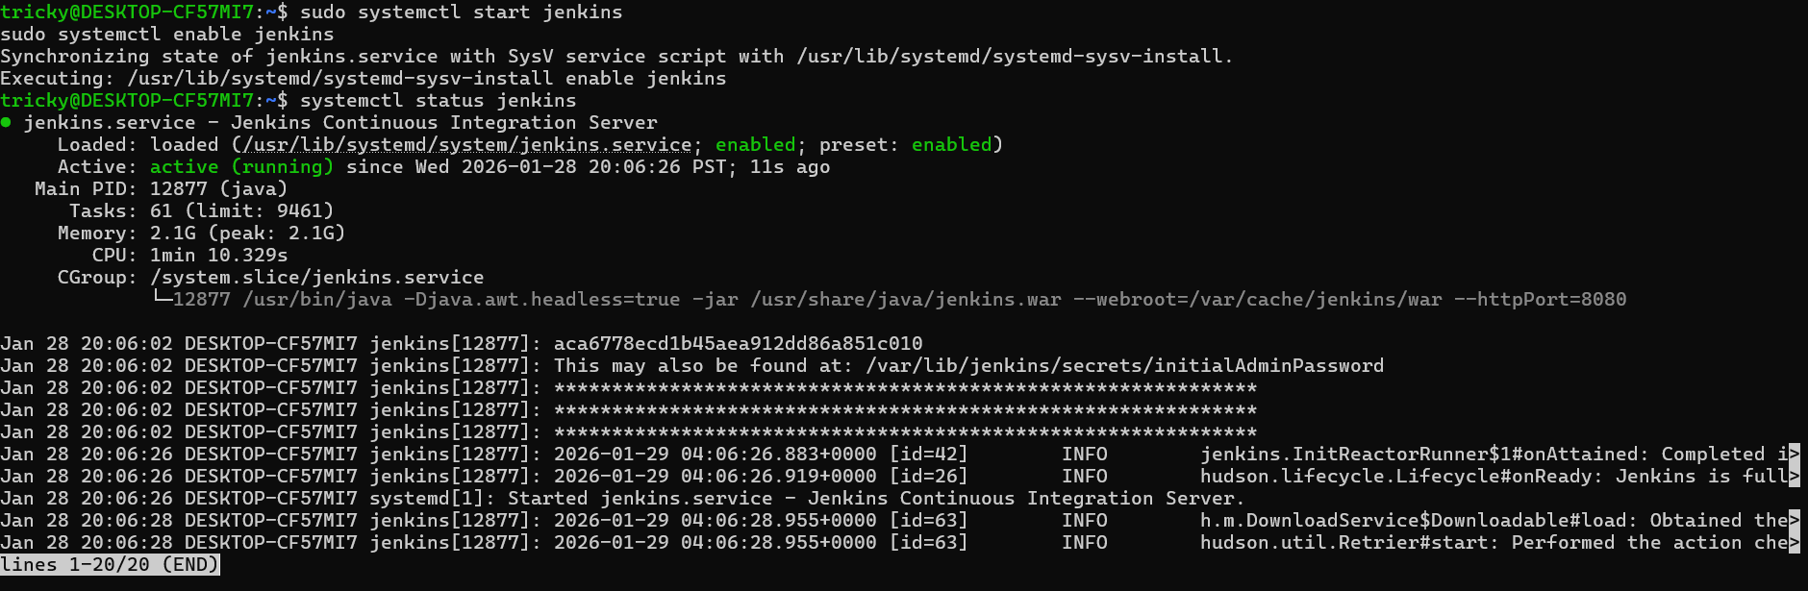

Assignment 6 – Package Management (Java) • • • Check whether Java is installed Install the required Java version for Jenkins Verify the Java version
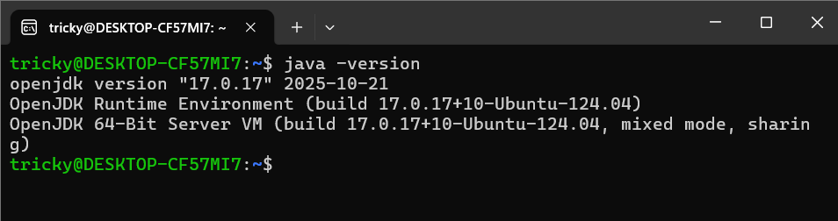
Assignment 7 – User Creation Script Write a shell script that: - Creates the following users: dev1 dev2 qa1 intern- Sets default shell to /bin/bash - Forces password change on first login
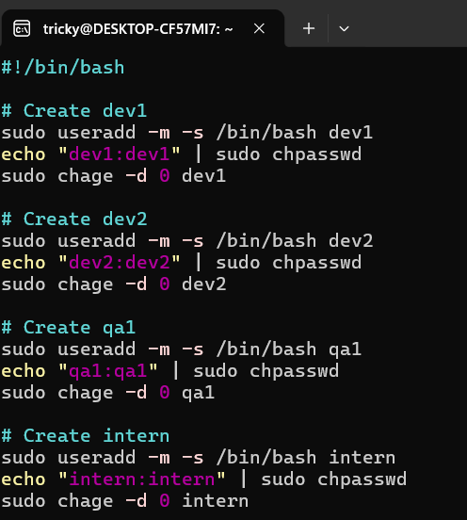
SAVE AND QUIT - :wq
Give execute permission with chmod u+x installjenkins.sh
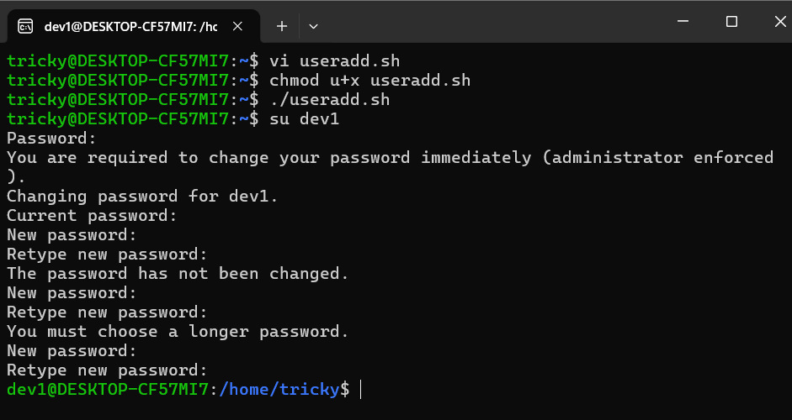
Assignment 8 – Disk Usage & Cleanup • • • Check disk usage from the command line Identify top directories consuming disk space under /var Write down the commands used and their output
df -h
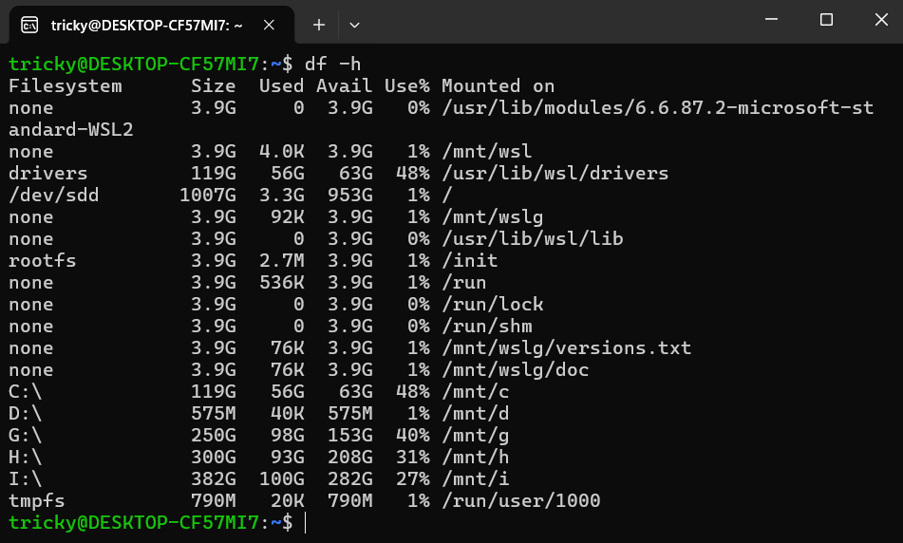
sudo du -sh /var/*
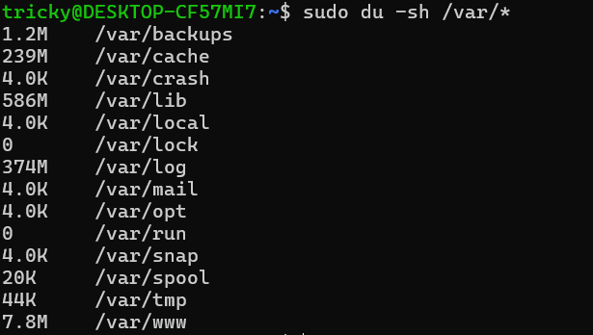
Command Used – df -h
sudo du -sh /var/*

Assignment 9 – System Report Script
Write a shell script that prints: - Current user - Date and time - Disk usage Save the output to system_report.txt
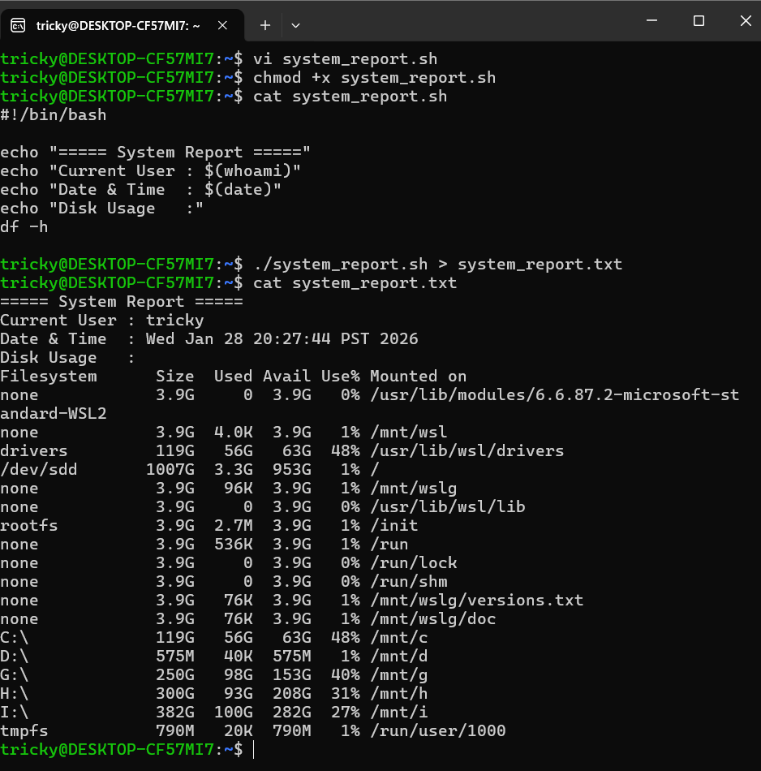

Assignment 10 – Hard Shell Script
Create a shell script named server_health.sh that: - Checks disk usage - Checks memory usage Checks whether Jenkins service is running - Prints a WARNING if disk usage is greater than 80% - Prints an ALERT if Jenkins is not running - Adds timestamp to every output - Saves all output to health.log
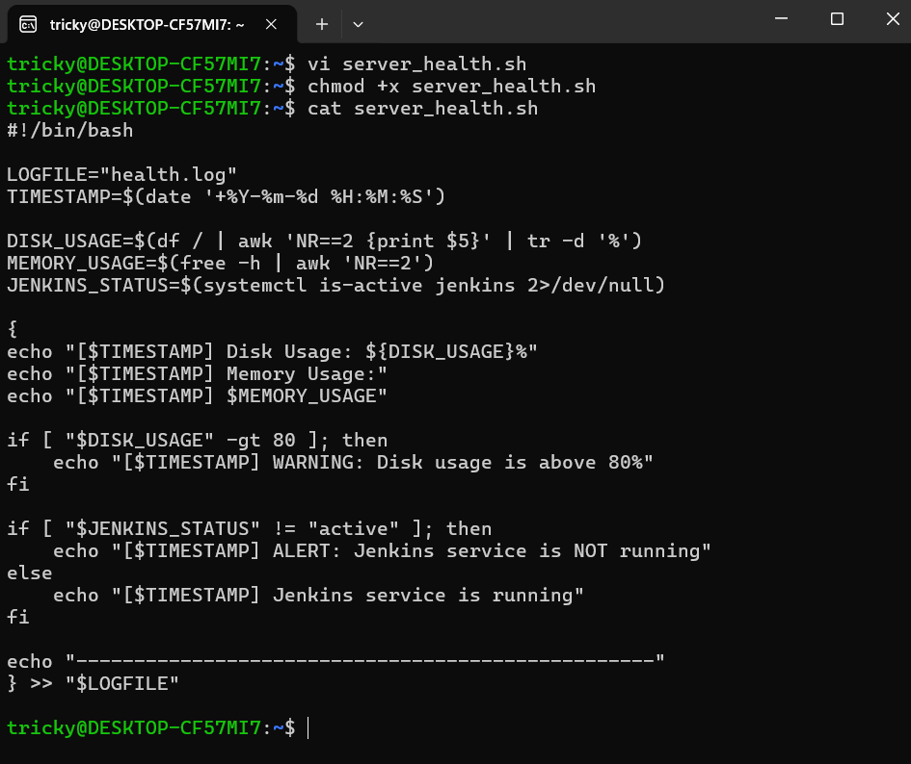
Make it executable - chmod u+x server_health.sh

